- Mob- 8126283110,
- 9410519103
- Email-tksgicthatidhanari@gmail.com
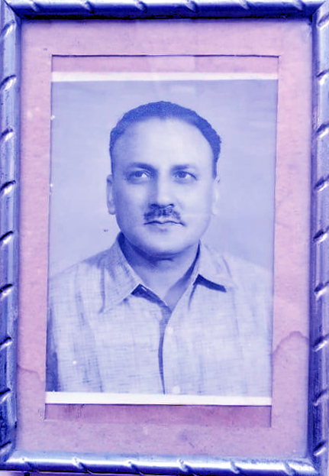



- principalthatidhanari123@gmail.com
A.U.T.K.S. GOVT. INTER COLLEGE
Thati Dhanari
Atal Utkrisht Thakur Kishan Singh Govt. Inter Collage
Thati Dhanari Dunda Uttarkashi

Late.THAKUR KISHAN SINGh
About Us
ATAL UTKRISHT THAKUR KISHAN SINGH Senior Secondary School Thati Dhanari Dunda Uttarkashi has been established in the year 1965 Secondary Level and 1975 upgreded in Senior Secondary. It is situated ATAL UTKRISHT THAKUR KISHAN SINGH area of Thati Dhanari Dunda Uttarkashi in 4.5 acres of land with vast infrastructure, state of the art facilities including audio visual teaching system, computers, ICT Lab., Physic, chemistry, Biology Science Lab., library, reading room, MDM, Play room, Transcendental Meditation hall, Play ground etc.
ATAL UTKRISHT THAKUR KISHAN SINGH Senior Secondary School is affiliated to CBSE Delhi (6th to class 12th) in March 2021. The genius of AUTKSGIC school curriculum is that every student studying different subjects identified by the NCERT and Central Board of Secondary Education has a unique approach to complete and holistic education.
Academics
4.5
ACRES LAND
334
STUDENTS
22
TOTAL STAFF
1965
ESTABLISHED IN YEAR
School Name: | Atal Utkrisht Thakur Kishan Singh Govt. Inter Collage School
Address: | Thati Dhanari Dunda Uttar kashi
State: | Uttarakhand Schools in Uttarakhand
City: | UTTARKASHI
Pincode: | 249151
Country: | India Find schools in India
Telephone Number: | 8126283110
Email: | tksgicthatidhanari@gmail.com
Website: | autksgicthati.in
Board: | UK & CBSE
Management: | Govt. School
School Type: | Higher Secondary School
  - Faculty
  - Exam Schedules
  - Results
  - Students Enrollment
  - AUTKSGIC Book List
  - Transfer Certificate (TC)
  - Latest Circulars
- Admission
- Achievements
- Management
- Gallery
Contact Us--Total Knowledge for Everyone
ʺLet us mould your children′s future and prepare them for leadership in the worldʺ
Atal Utkrisht Thakur Kishan Singh Govt. Inter Collage
School
Thati Dhanari Dunda
Uttarkashi (249151) - Uttarakhand
- Mobile: 8126283110
- E-mail: tksgicthatidhanari@gmail.com
- gicthatidhanari@gmail.com

Find Us
ATAL UTKRISHT THAKUR KISHAN SINGH
(Senior Secondary School for Boys & Girls)
Thati Dhanari Dunda
Uttarkashi (249151) - Uttarakhand

Atal Utkrisht Thakur Kishan Singh Govt. Inter Collage Thati Dhanari Dunda Uttarkashi and is registered under the Society Registration Act of 21, 1860. It is situated at pipli Dhanari Dunda Uttarkashi. It is located on the bank of the river Dhanpati. Uttarkashi itself is a valley, situated in the lap of the Himalayas at an altitude of 1300mts above sea level. The school consists of Three large double storey buildings with airy rooms, accommodated with all types of facilities. The school has One playgrounds for games and sports.

AIMS AND OBJECTIVES :
The cardinal principles, aims and objectives under which the school functions are as follows:-
- To impart sound education with English as a medium of instruction.
- To attempt at the development of every individual child taking into consideration the mental, physical, social and spiritual needs of the child, so that the child may grow up as responsible citizen.
- To inculcate values of attitudes and habits, which will help in the creation of new social order, based on human dignity, equality of opportunity.
- The school is famous in Uttarkashi, for providing Secondary and Senior Secondary education based on the CBSE pattern.
- The school believes that education should lead the students to a practical, confident and successful life and that every child has the potential to be the light of the world and our endeavor is to see the budding children as the dream kids and pride achievers in the forthcoming days.

School Timings and Periods:
The school runs from Monday to Saturday and has eight periods per day with a recess break.
Timings : Winter : 9:15am to 3:30pm
Summer : 7:15am to 1:30pm
About GIC THATI DHANARI
GIC THATI DHANARI was established in 1964 and it is managed by the Department of Education. It is located in Rural area. It is located in DUNDA block of UTTARKASHI district of Uttarakhand. The school consists of Grades from 6 to 12. The school is Co-educational and it doesn't have an attached Upper-primary section. The school is N/A in nature and is not using school building as a shift-school. Hindi is the medium of instructions in this school. This school is approachable by all weather road. In this school academic session starts in April.
The school has Government building. It has got 10 classrooms for instructional purposes. All the classrooms are in good condition. It has 2 other rooms for non-teaching activities. The school has a separate room for Head master/Teacher. The school has Pucca boundary wall. The school has have electric connection. The source of Drinking Water in the school is Hand Pumps and it is functional. The school has 03 boys toilet and it is functional. and 03 girls toilet and it is functional. The school has no playground. The school has a library and has 3000 books in its library. The school does not need ramp for disabled children to access classrooms. The school has 10 computers for teaching and learning purposes and all are functional. The school is not having a computer aided learning lab. The school is Provided and Prepared in School Premises providing mid-day meal.

Basic Infrastructure :
Village / Town: Thati/Pipli
Cluster: Pipli
Block: Dunda
District: Uttarkashi
State: Uttarakhand
UDISE Code : 05010304404
Building: Government
Class Rooms: 10
Boys Toilet: 03
Girls Toilet: 03
Computer Aided Learning: Yes
Electricity: Yes
Wall: 3 Side Boundary Wall
Library: Yes
Playground: Yes
Books in Library: 3000
Drinking Water: Yes
Ramps for Disable: No
Computers: 10
Instruction Medium: Hindi
Male Teachers: 17
Pre Primary Sectin Avilable: No
Board for Class 10th State Board
School Type: Co-educational
Classes: From Class 6 to Class 12
Female Teacher: 3
Pre Primary Teachers: 0
Board for Class 10+2 State Board
Meal Provided and Prepared in School Premises
Establishment: 1964
School Area: Rural
School Shifted to New Place: No
Head Teachers: 1
Head Teacher: Chandrabhan
Is School Residential: No
Residential Type: N/A
Total Teachers: 15
Geast Teachers: 04
Management: Department of Education
Academic - Upper Primary with Secondary and Higher Secondary (6-12):
Details of sanctioned, working and vacant posts
S.N. | Designation | Sanctioned posts | Working posts | Vacant posts
01 | Principal | 01 | & | 01
02 | Lecturer in Hindi | 01 | 01 | &
03 | Lecturer in English | 01 | Guest Teacher | 01
04 | Lecturer in Sanskrit | 01 | 01 | &
05 | Lecturer in Mathamatics | 01 | 01 | &
06 | Lecturer in Chemistary | 01 | 01 | &
07 | Lecturer in Physic | 01 | 01 | &
08 | Lecturer in Biology | 01 | 01 | &
09 | Lecturer in Economics | 01 | Guest Teacher | 01
10 | Lecturer in Poltical science | 01 | 01 | &
11 | Lecturer in Geology | 01 | 01 | &
12 | Assistant Teacher Hindi | 02 | 01 Guest Teacher | 01
13 | Assistant Teacher English | 01 | Guest Teacher | 01
14 | Assistant Teacher Gymnastic | 01 | 01 | &
15 | Assistant Teacher Maths | 02 | 01 | 01
16 | Assistant Teacher Science | 01 | 01 | &
17 | Assistant Teacher General | 03 | 01 | 02
18 | Assistant Teacher Art | 01 | 01 | &
19 | Administration officer | 01 | 01 | &
20 | Junior Assistant | 01 | 02 (Majority) | 01
21 | peon | 06 | 05 | 01
;ksx |  | 31 | 23  04 Guest Teacher | 10

